**Topics: Descriptive Statistics and Probability**

1. Look at the data given below. Plot the data, find the outliers and find out $μ, σ, σ^{2}$

|  |  |
| --- | --- |
| **Name of company** | **Measure X** |
| Allied Signal | 24.23% |
| Bankers Trust | 25.53% |
| General Mills | 25.41% |
| ITT Industries | 24.14% |
| J.P.Morgan & Co. | 29.62% |
| Lehman Brothers | 28.25% |
| Marriott | 25.81% |
| MCI | 24.39% |
| Merrill Lynch | 40.26% |
| Microsoft | 32.95% |
| Morgan Stanley | 91.36% |
| Sun Microsystems | 25.99% |
| Travelers | 39.42% |
| US Airways | 26.71% |
| Warner-Lambert | 35.00% |

SOL:-

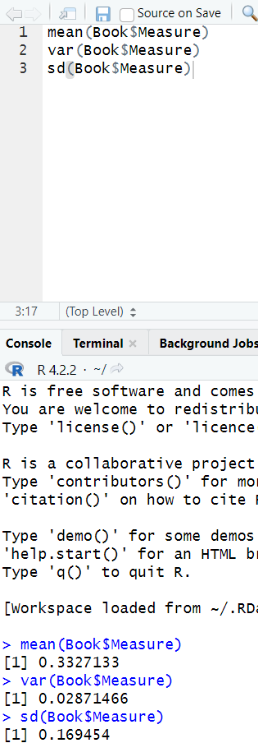



Answer the following three questions based on the box-plot above.

1. What is inter-quartile range of this dataset? (please approximate the numbers) In one line, explain what this value implies.

ANS:- (Inter-Quartile Range) IQR = (Q3-Q1) = 12-5 = 7

1. What can we say about the skewness of this dataset?

ANS:- The skewness of the box plot is positive skewness.

1. If it was found that the data point with the value 25 is actually 2.5, how would the new box-plot be affected?

ANS:- The new boxplot is affected as there are no outliers.



Answer the following three questions based on the histogram above.

1. Where would the mode of this dataset lie?

ANS:-From the above histogram we can say that the mode value is lying in between 4 and 6.

1. Comment on the skewness of the dataset.

ANS:- The skewness of the dataset is lying on the right side i.e positive side of the histogram and not normally distributed.

1. Suppose that the above histogram and the box-plot in question 2 are plotted for the same dataset. Explain how these graphs complement each other in providing information about any dataset.

ANS:- The boxplot says clearly where the outliers are present and the histogram says which is the peak value in the dataset and it also says that the data is normally distributed are not and both the diagrams are right skewed or positively skewed.

1. AT&T was running commercials in 1990 aimed at luring back customers who had switched to one of the other long-distance phone service providers. One such commercial shows a businessman trying to reach Phoenix and mistakenly getting Fiji, where a half-naked native on a beach responds incomprehensibly in Polynesian. When asked about this advertisement, AT&T admitted that the portrayed incident did not actually take place but added that this was an enactment of something that “could happen.” Suppose that one in 200 long-distance telephone calls is misdirected. What is the probability that at least one in five attempted telephone calls reaches the wrong number? (Assume independence of attempts.)

ANS:- The probability that at least one in five attempted telephone calls reaches the wrong number is approx. 0.012 (OR) 1.23%

1. Returns on a certain business venture, to the nearest $1,000, are known to follow the following probability distribution

|  |  |
| --- | --- |
| x | P(x) |
| -2,000 | 0.1 |
| -1,000 | 0.1 |
| 0 | 0.2 |
| 1000 | 0.2 |
| 2000 | 0.3 |
| 3000 | 0.1 |

1. What is the most likely monetary outcome of the business venture?

ANS:- The most likely monetary outcome of the business venture is $2,000.

1. Is the venture likely to be successful? Explain

ANS:- The expected value of the venture is positive, we can conclude that the venture is likely to be successful in terms of generating profit.

1. What is the long-term average earning of business ventures of this kind? Explain

ANS:- The long-term average earnings of business ventures of this kind is $800 per venture. This means that if we were to repeat this venture many times under similar conditions, we would except to earn an average of $800 per venture in the long run.

1. What is the good measure of the risk involved in a venture of this kind? Compute this measure

ANS:- The Standard Deviation of the monetary outcome is approx $456.52. This indicates that there is a significant degree of variability or uncertainty in the possible outcomes, and therefore a substantial amount of risk associated with this venture.